J.N.T.U.H. COLLEGE OF ENGINEERING

**KUKATPALLY, HYDERABAD – 500 085**

**CERTIFICATE**

***This is to certify that*** ____Rigveda.V_ ***of B. Tech II year II Semester bearing the Hall-Ticket Number 17011A0528 has fulfilled his/her SCRIPTING LANGUAGES record for the academic year 2018-2019.***

***Signature of the Head of the Department                                Signature of the staff member***

***Date of Examination_________________________***

***Internal Examiner                                                                    External Examiner***

|  |  |  |
| --- | --- | --- |
| 1. | PERL program to find largest number | 3 |
| b. | PERL program to print multiplication tables | 5 |
| 2. | PERL program to implement manipulation functions | 11 |
| 3. | PERL script to substitute a word with another | 13 |
| 4. | PERL script to validate email ID and IP address | 14 |

|  |  |  |
| --- | --- | --- |
| 1. | PHP script to print prime numbers | 16 |
| 2a | PHP script to find length of string | 17 |
| b | Count number of words | 18 |
| c | Reverse a string | 19 |
| d | Search for a specific string | 20 |
| 3 | PHP script to merge 2 arrays and sort | 21 |
| 4 | PHP program to copy data from one file to another | 22 |

|  |  |  |
| --- | --- | --- |
| 1 | Python program to solve quadratic equation | 24 |
| 2 | Python program to find factorial | 25 |
| b | Python program to generate Fibonacci series | 26 |
| 3 | Python program to make simple calculator | 27 |
| 4 | Python program to sort words in alphabetical order | 29 |
| 5 | Python program to add 2 matrices | 30 |

* Perl Programs

1. **Aim : To write a PERL script to find largest among 3 numbers.**

print "Largest of three numbers\n";

print "a: ";

$a=<stdin>;

print "b: ";

$b=<stdin>;

print "c: ";

$c=<stdin>;

if($a>$b)

{

if($a>$c)

{

print "a=$a is largest\n";

}

if($a<$c)

{

print "c=$c is largest\n";

}

if($a==$c)

{

print "a,c=$c are largest\n";

}

}

if($b>$a)

{

if($b>$c)

{

print "b=$b is largest\n";

}

if($b<$c)

{

print "c=$c is largest\n";

}

if($b==$c)

{

print "b,c=$c are largest\n";

}

}

if($a eq $b)

{

if($c>$a)

{

print "c=$c is largest\n";

}

if($c<$a)

{

print "a,b=$a are the largest\n";

}

if($c==$a)

{

print "a,b,c=$a are equal";

}

}

**Output:**

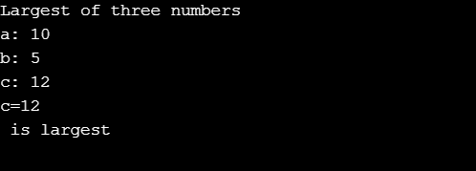

1. **Aim : To write multiplication tables from 1-10 using subroutines**

sub multable

{

for($j=1;$j<11;$j=$j+1)

{

$pro=$_[0]*$j;

print "$_[0] x $j = ($pro)\n";

}

}

print "Multiplication tables\n";

for($i=1;$i<11;$i=$i+1)

{

print "$i table\n";

multable($i);

}

Output:

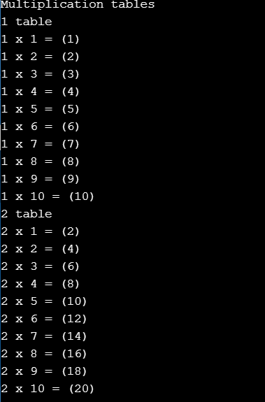

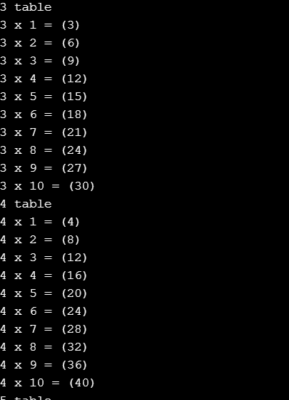

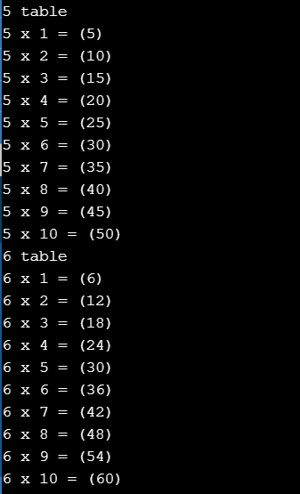

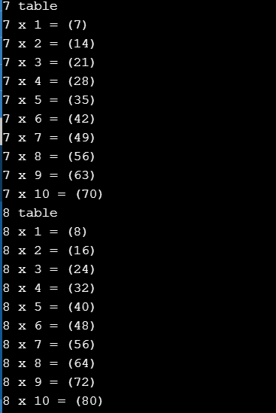 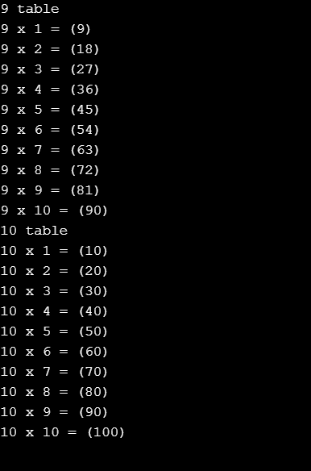

1. **Aim : Write a PERL program to implement the following list of manipulating functions.**
2. **Shift**
3. **Unshift**
4. **Push**

print "Shift\n";

@ele=('j','n','t','u','h','c','e','h');

print "@ele\n";

$shiftedele=shift(@ele);

print "Shifted ele= $shiftedele\n";

print "@ele\n";

print "Element inserted at beginning(unshift)\n";

chomp($first=<stdin>);

unshift(@ele,$first);

print "@ele\n";

print"Element inserted at end(push)\n";

$last=<stdin>;

push @ele,$last;

print "@ele\n";

Output:

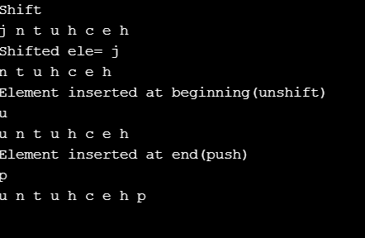

1. **Aim : To write a PERL script to substitute a word with another word in a string.**

print("Replace substring\n");

print("Main string\n");

chomp($mains=<stdin>);

print("Word\n");

chomp($w=<stdin>);

print("New word\n");

chomp($new=<stdin>);

$posw=index($mains,$w);

$lenw=length($w);

substr($mains,$posw,$lenw)=$new;

print($mains);

**Output:**

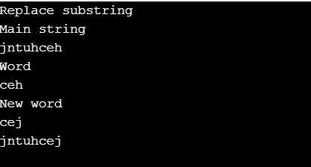

**4) Aim : To validate IP address and email address**

print("Validate email address\n");

print("Email address\n");

chomp($email=<stdin>);

if($email=~/([a-zA-Z0-9]+)\@([a-zA-z0-9]+).(com|net|org)/)

{

print "Valid";

}

else

{

print "Invalid";

}

print("Validate IP address\n");

print("IP address\n");

chomp($ip=<stdin>);

if($ip=~/([0-9]{0,3})[.]([0-9]{0,3})[.]([0-9]{0,3})[.]([0-9]{0,3})/)

{

print "Valid";

}

else

{

print "Invalid";

}

**Output:**

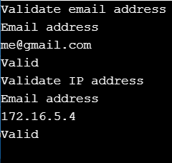

* PHP Programs

1. **Aim : To write a PHP program to print prime numbers from 1-50**

<?php

for($i=1;$i<51;$i++)

{

$fact=0;

for($j=1;$j<=$i;$j++)

{

if($i%$j==0)

{

$fact++;

}

}

if($fact==2)

{

echo $i.'<br>';

}

}

**Output :**



**2) Aim : To write a PHP program to find length of string**

<?php

$str1="hello ";

$str2="hey , this is me";

$len=strlen($str1);

echo("string length :");

echo($len."<br>");

?>

**Output:**

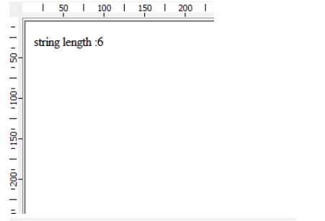

**b) Aim : To write a PHP program to count number of words in a given string .**

<?php

$str2="hey , this is me";

echo("no. of words :");

$w=str_word_count($str2);

echo($w);

?>

**Output:**

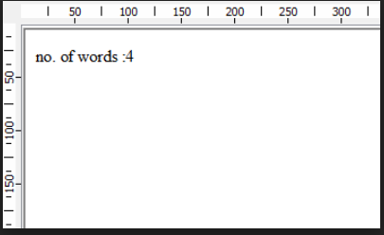

**c) Aim : To write a PHP program to reverse a string**

<?php

$str1="hello ";

$str2="hey , this is me";

$str1=$str1.$str2;

echo("string is : ");

echo($str1."<br>");

echo("reverse : ");

echo(strrev($str2)."<br>");

?>

**Output:**

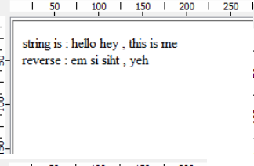

1. **Aim : To write a PHP program to search for a specific string**

<?php

$str1="hello ";

$str2="hey , this is me";

if(strpos($str2,"welcome")=== false)

{

echo("not found");

}

?>

**Output:**

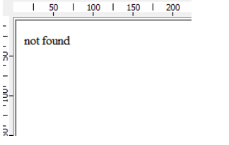

1. **Aim : To write a PHP program to merge 2 arrays and sort them as numbers in descending order.**

<?php

$a=array(1,2,3,4);

$b=array(5,6,7,8);

$c=count($b);

$d=count($a);

for($i=0;$i<$c;$i++)

{

$a[$d+$i]=$b[$i];

}

sort($a);

$a=array_reverse($a);

print_r($a);

?>

**Output :**

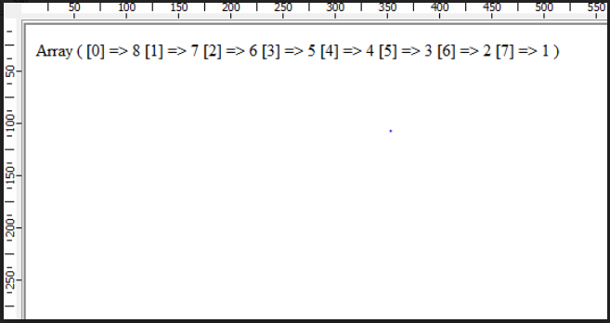

1. **Aim : Write a PHP program that copies contents from one file and writes into another file**

<?php

$fp=fopen("rig.txt","r");

if($fp == false)

{

echo("couldnt open file"."<br>");

exit();

}

$fsize=filesize("file1.txt");

$fdata=fread($fp,$fsize);

$fp2=fopen("file2.txt","w");

if($fp2== false)

{

echo("couldnt create file"."<br>");

exit();

}

fwrite($fp2,$fdata);

echo("contents written");

fclose($fp2)

?>

**Output:**

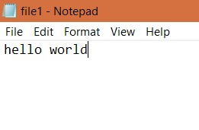

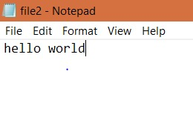

* Python Programs

1. **Aim : To write a program to find roots of a quadratic equation.**

import cmath

print("ax^2+bx+c")

a=int(input("Enter a :"))

b=int(input("Enter b :"))

c=int(input("Enter c :"))

root1=(-1*b + cmath.sqrt(b**2-4*a*c))/2*a

root2=(-1*b - cmath.sqrt(b**2-4*a*c))/2*a

print("roots are :",root1,',',root2)

**Output:**

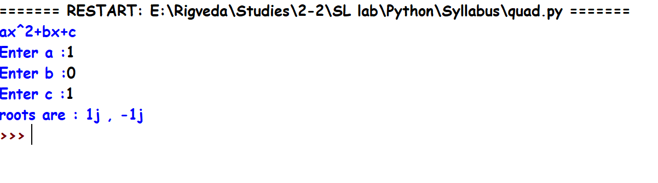

1. **Aim : To find factorial of a given number.**

n=int(input("enter a number whose factorial is to be found :"))

fact=1

for i in range(1,n+1):

fact=fact*I 0`0`000000000``000000000000000000```````````

print("Factorial is :",fact)

Output:

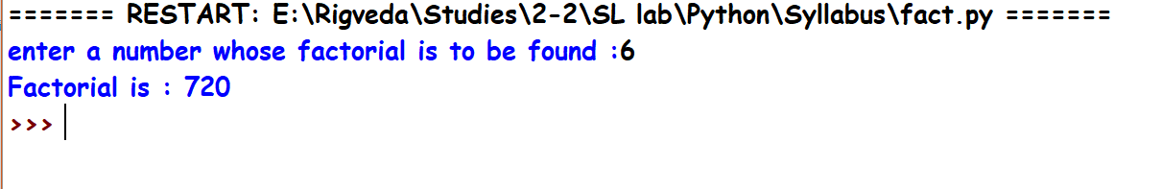

**b) Aim : To generate Fibonacci series.**

n=int(input("enter number of terms to be printed in fibonacci series :"))

print(0,1,sep=(','),end=(','))

pres=1;

prev=0;

temp=0

i=0

while(i<n-2):

temp=pres

pres=pres+prev

prev=temp

print(pres,end=',')

i+=1

**Output:**

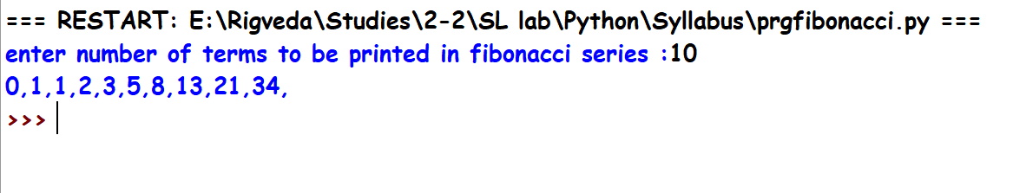

1. **Aim : To make a simple calculator.**

op=['+','-','*','/']

op=['+','-','*','/']

while(True):

a=float(input("Enter first number :"))

b=float(input("Enter second number :"))

o=input("enter operation to be performed :")

if o not in op:

print("invalid operation")

break

elif o==op[0]:

print("Sum is :",a+b)

elif o==op[1]:

print("Difference is :",a-b)

elif o==op[2]:

print("Product is :",a*b)

else:

print("Quotient is :",a/b)

print("continue?")

if(input()!="y"):

break

**Output:**

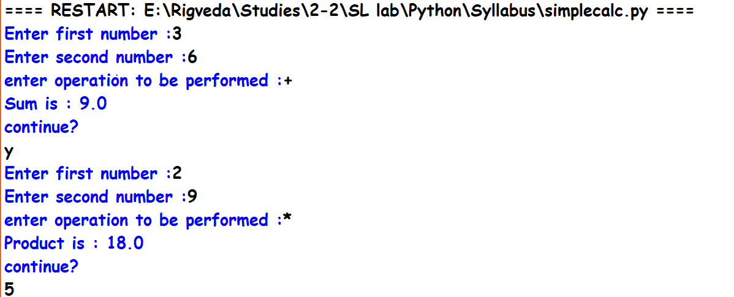

1. **Aim : To sort words in alphabetical order.**

lst=sorted(input("\n Enter space separated words :").split())

print("Sorted order of words are :")

for i in lst:

print (i)

**Output:**

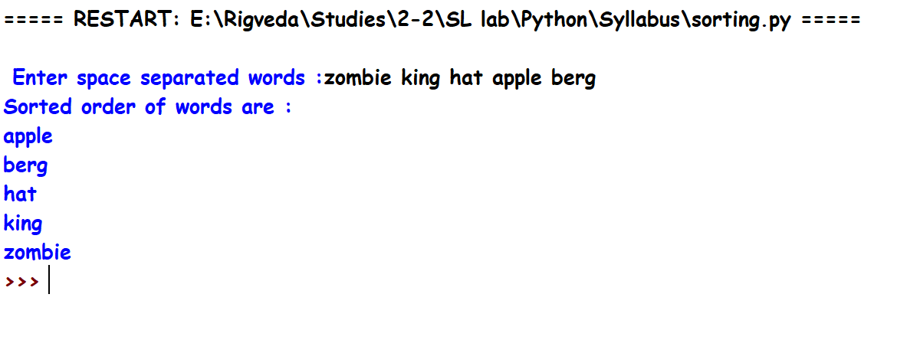

1. **Aim : To add 2 matrices.**

m=input("enter number of rows of matrix 1 :")

n=input("enter number of columns of matrix 1 :")

p=input("enter number of rows of matrix 2 :")

q=input("enter number of columns of matrix 2 :")

if m!=p or n!=q:

print("cannot perform addition")

exit

else:

rows=int(m)

col=int(n)

m1=[]

m2=[]

m3=[]

print('taking values of first matrix :')

for i in range(0,rows):

print('enter elements of row',i+1,':')

lst=[]

for j in range(0,col):

print("element",j+1)

num=int(input())

lst.append(num)

m1.append(lst)

print(m1)

print('taking values of second matrix :')

for i in range(0,rows):

print('enter elements of row',i+1,':')

lst=[]

for j in range(0,col):

print("element",j+1)

num=int(input())

lst.append(num)

m2.append(lst)

print(m2)

for i in range(0,rows):

lst=[]

for j in range(0,col):

lst.append((m1[i][j])+(m2[i][j]))

m3.append(lst)

print('sum is ',m3)

**Output:**

